When launched, the application should wait for http connections.

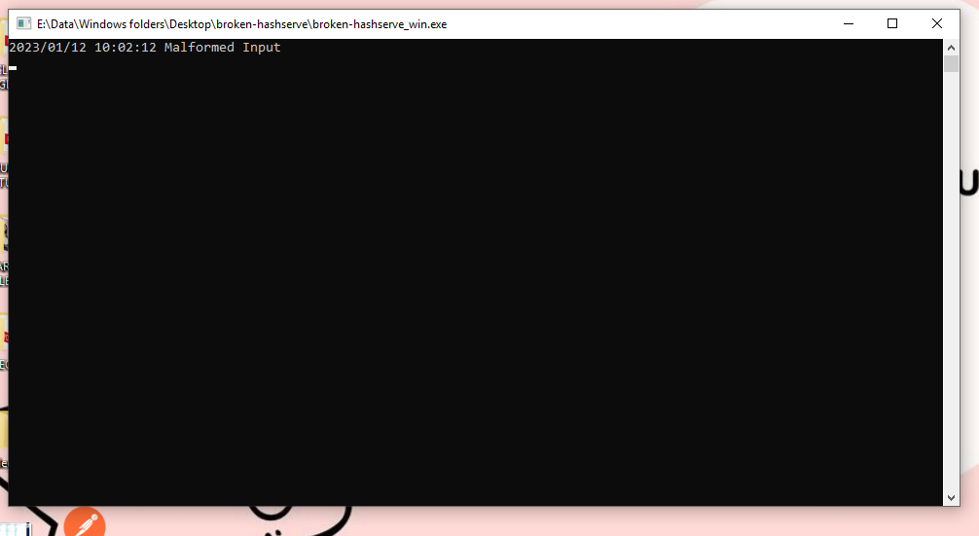

● It should answer on the PORT specified in the PORT environment variable.

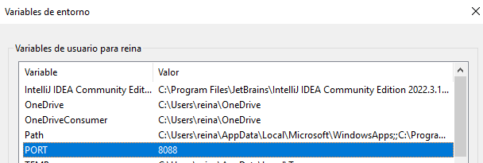

● It should support three endpoints:

○ A POST to /hash should accept a password. It should return a job identifier

immediately. It should then wait 5 seconds and compute the password hash.

The hashing algorithm should be SHA512.

**Fail Bug1**

○ A GET to /hash should accept a job identifier. It should return the base64

encoded password hash for the corresponding POST request.

**Fail Bug2**

○ A GET to /stats should accept no data. It should return a JSON data structure

for the total hash requests since the server started and the average time of a

hash request in milliseconds.

Passed

● The software should be able to process multiple connections simultaneously.

● The software should support a graceful shutdown request. Meaning, it should allow any

in-flight password hashing to complete, reject any new requests, respond with a 200 and

shutdown.

**Fail Bug 3**

● No additional password requests should be allowed when shutdown is pending.